Software Engineering Assigenments

**MODULE: 1 (SDLC)**

1. What is software? What is software engineering ?

Software is a generic term used to refer to applications, scripts and programs that run on a device. It can be thought of as the variable part of a computer, while hardware is the invariable part.

Software engineering is defined as a process of analyzing user requirements and then designing, building, and testing software application which will satisfy those requirements.

2. Explain types of software

**The two main categories of software are**[**application**](https://www.techtarget.com/searchsoftwarequality/definition/application)**software and**[**system software**](https://www.techtarget.com/whatis/definition/system-software)**. An application is software that fulfills a specific need or performs tasks. System software is designed to run a computer's hardware and provides a platform for applications to run on top of.**

3. What is SDLC? Explain each phase of SDLC

**SDLC stands for Software Development Life Cycle. It consists of several phases:**

**1. Requirements Gathering: Understanding the needs of the software and documenting them.**

**2. System Design: Creating a detailed plan for the software's architecture and functionality.**

**3. Implementation: Writing the code and developing the software.**

**4. Testing: Checking the software for bugs and ensuring it meets the requirements.**

**5. Deployment: Releasing the software to users and making it available for their use.**

**6. Maintenance: Ongoing support, bug fixes, and updates to keep the software running smoothly.**

4. what is DFD ? create a DFD diagram on Flipkart.

A data-flow diagram is a way of representing a flow of data through a process or a system. The DFD also provides information about the outputs and inputs of each entity and the process itself. A data-flow diagram has no control flow — there are no decision rules and no loops.

**LEVEL 0**

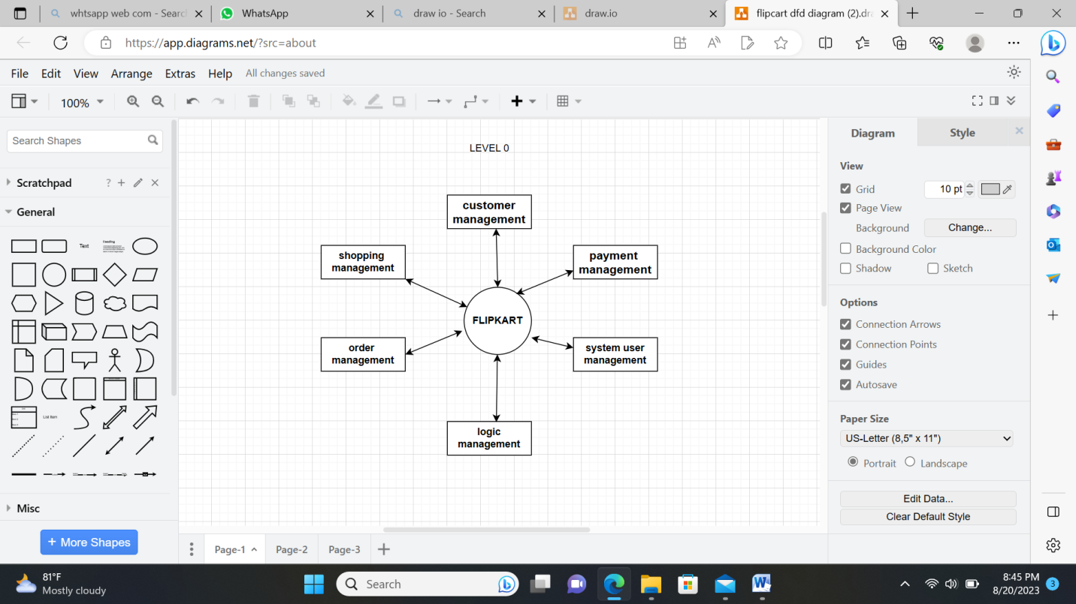

**LEVEL 1**

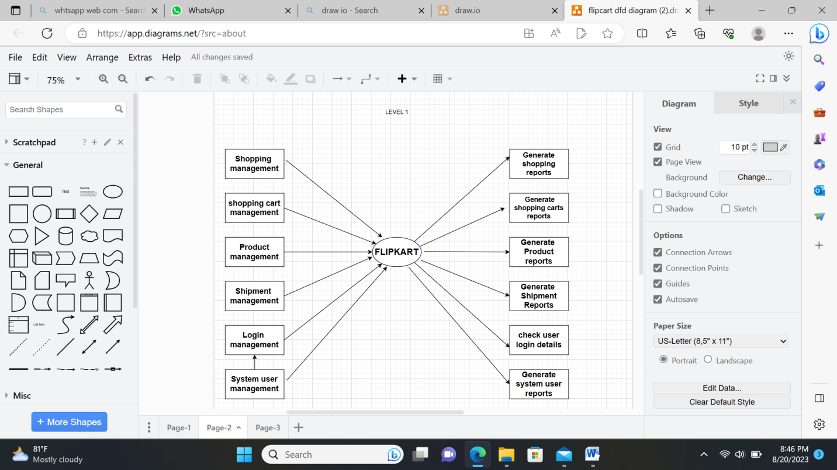

**LEVEL 2**

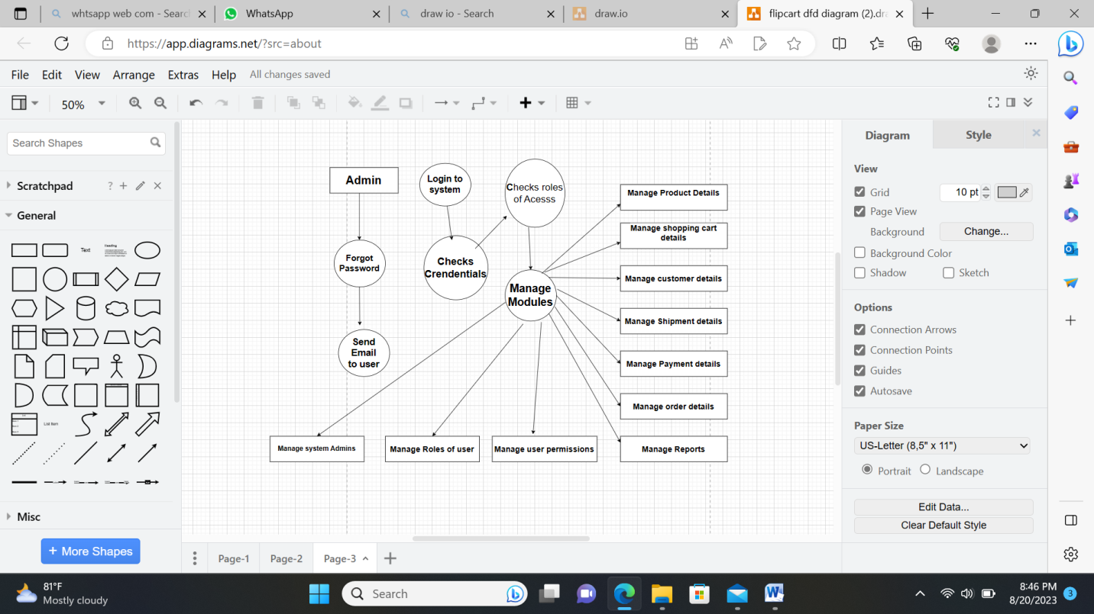

5. What is flowchart? Create a flowchart to make Addition of two numbers

a diagram that shows the connections between different stages of a process or parts of a system.

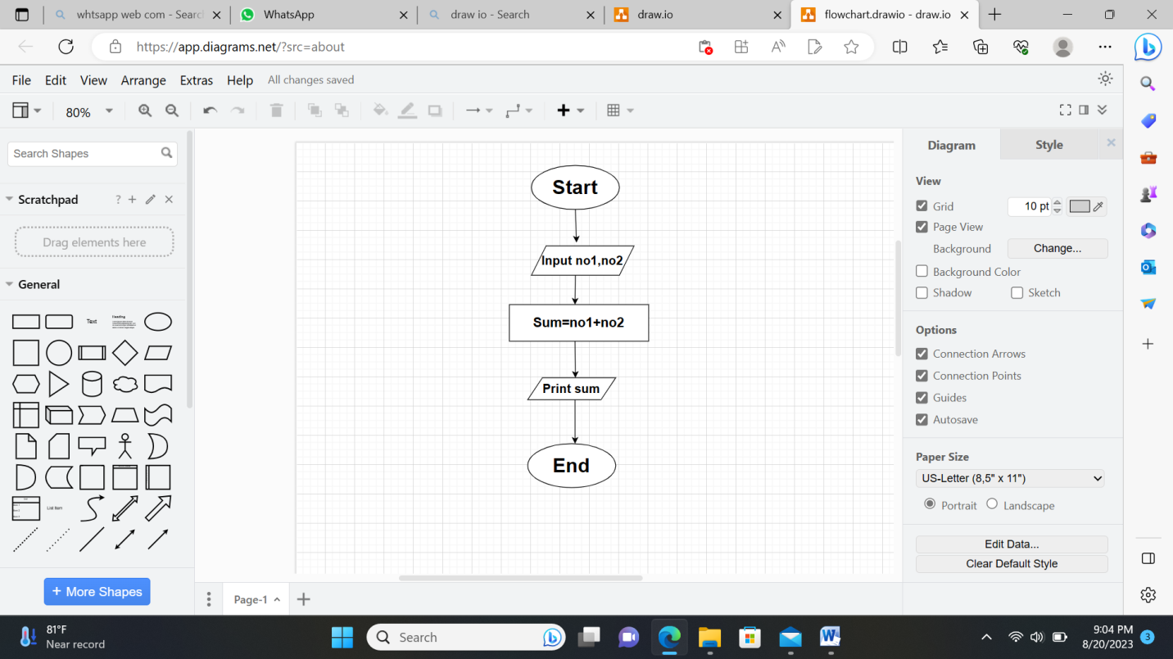

6. What is use case Diagram? Create a use case on bill payment on paytm.

A Use Case diagram illustrates a set of use cases for a system, i.e. the actors and the relationships between the actors and use cases. include relationship adds additional functionality not specified in the base use case.

